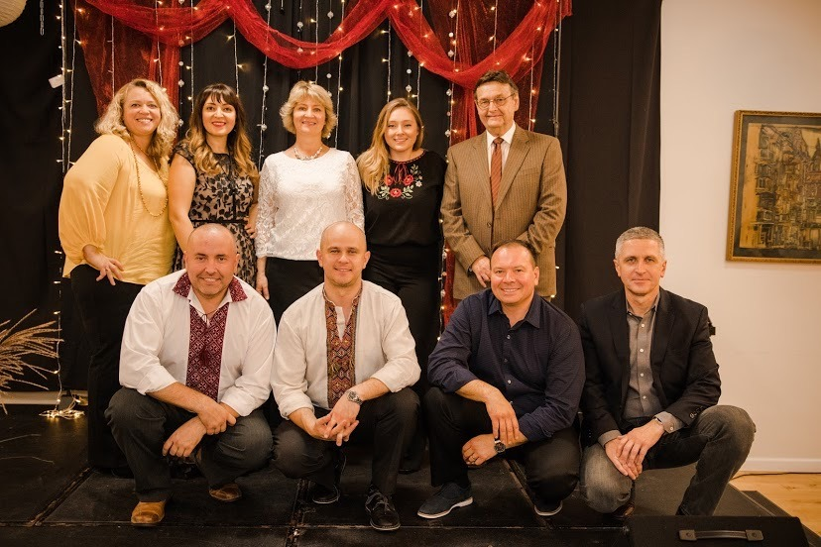

ABOUT US

We are a nonprofit organization based in Rochester, New York. Our teams is made up of local volunteers of all ages. We strive to help Ukrainian soldiers and other Ukrainians in need during their difficult time in war. We package and ship supplies, humanitarian aid, and rehabilitation equipment. We also host and take part in many events in order to promote awareness and raise money. Stay updated with our events so you don’t miss out! Any volunteering, donations, or help big or small would be much appreciated!